BIBD MINI PROJECT

-MongoDB

STEP 1: INSTALLATION PROCESS

We first need to install MongoDB in our pc.

We will do so by installing the installer.

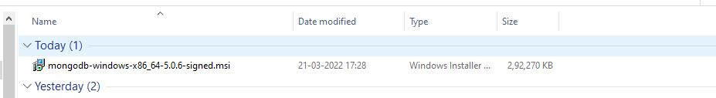

STEP2:

Then after installing installer successfully, we will run it on our pc and it will be downloaded successfully. In this case it is there on C drive.

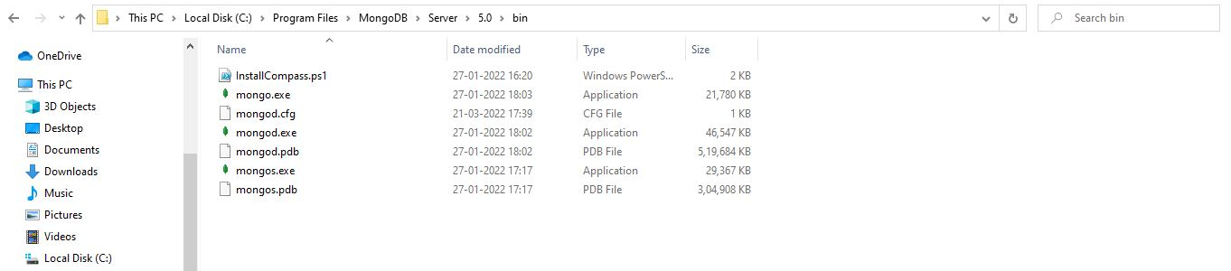

STEP 3:

After that we will open Command Prompt and we will assign the path folder on cmd.

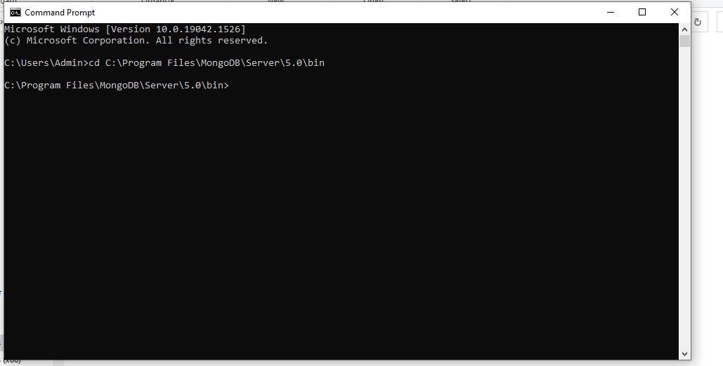

STEP 4:

After this we will type command:

mongo

It is used to connect to the database server on localhost.

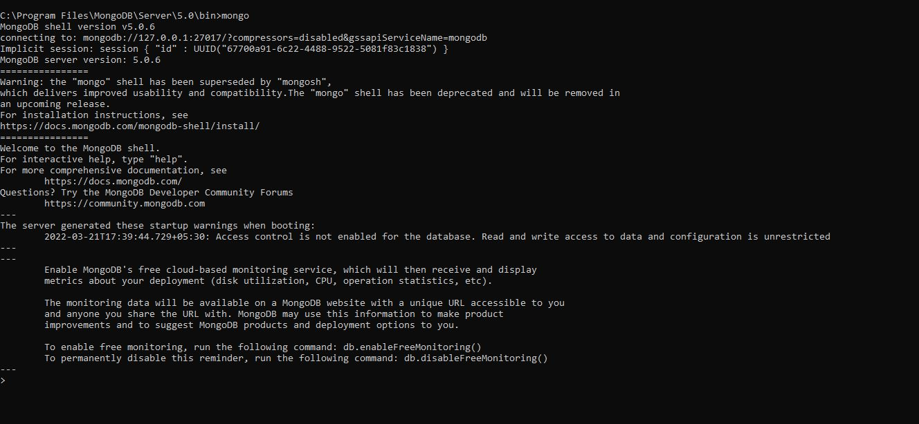

To show databases, command will be:

Show databases

Databases in the server will be shown

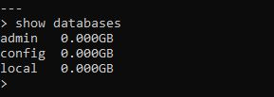

Can use the database admin here and then we will show the collections in the database.

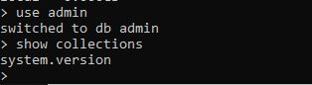

Now in case we stopped the MongoDB Server we will face this

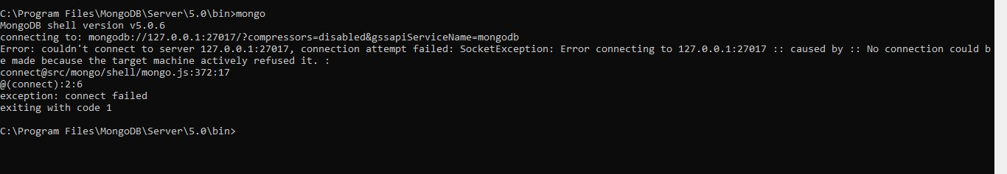

Then again we will start MongoDB server and then we will try to connect to server again. We have done it by using localhost and port number that is 27017 by default.

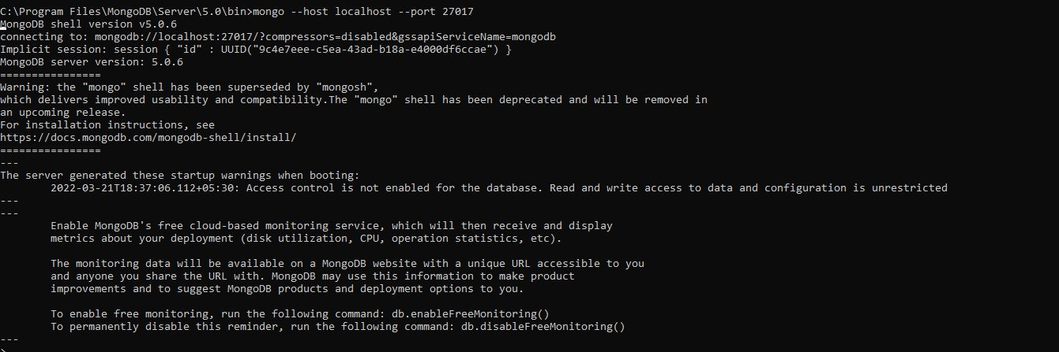

It has successfully connected to the server.

Now by stopping server again, we will put the another command which is a server program.

mongod

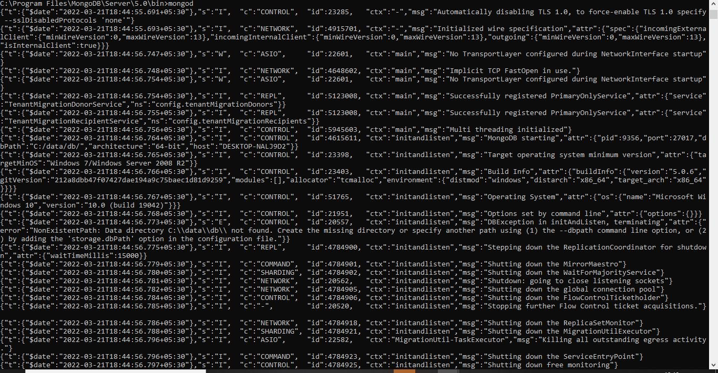

Now we faced an error. We need to create a new folder in C drive.

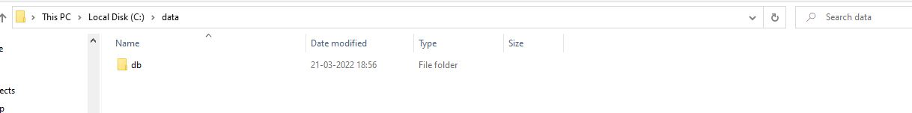

We will run the command mongod again

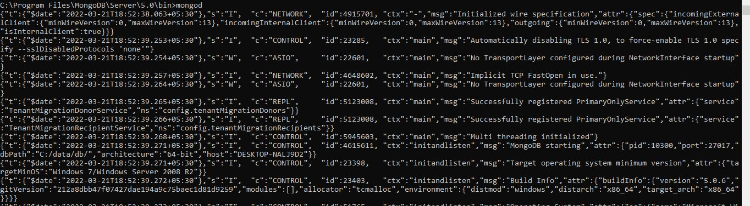

Now we will be creating a new user in admin database

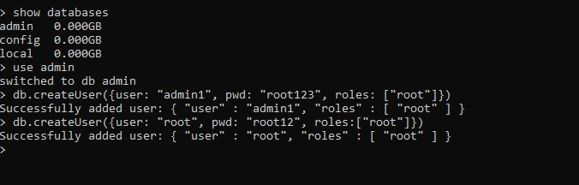

Showing the users

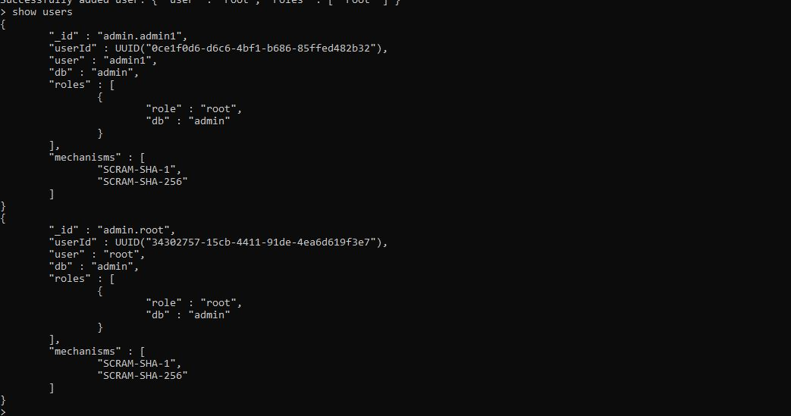

To create a database and insert a document to collection

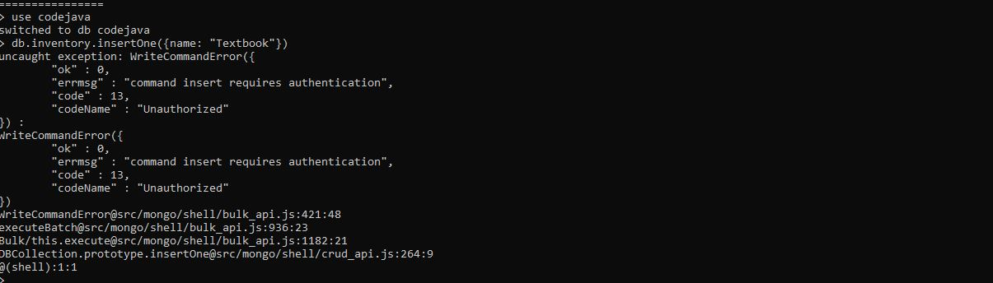

As it is showing that it is unauthorized, we need to provide username and password.

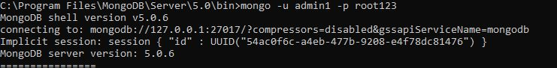

Now to check that it is successful.

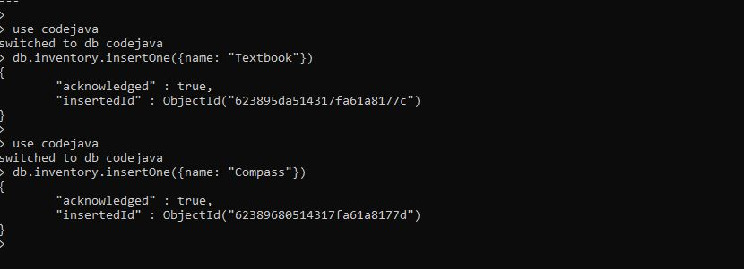

I again created an inventory for the 2nd user

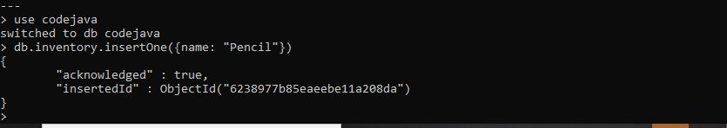

Now in order to find inventory.

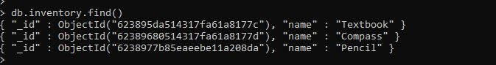

Now we will create an index . We have also created an unique index that allows us to ensure that there is at most 1 record in the collection with a given value for field.

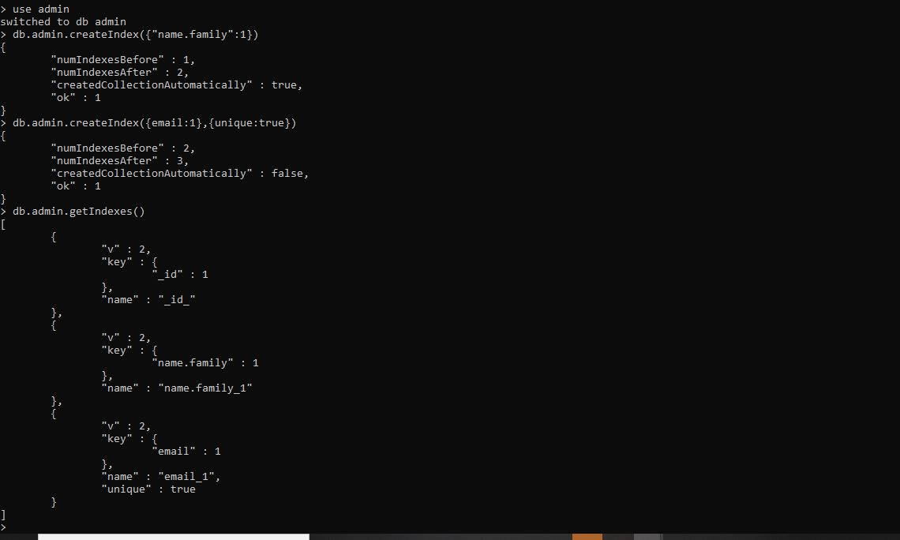

Now in order to drop an index we will use.

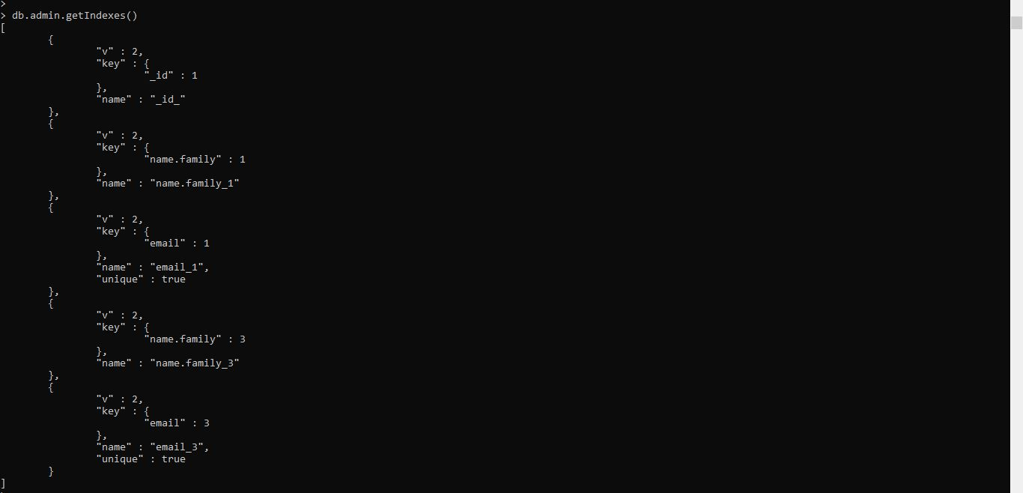



To shutdown the server we will use

